My four most favourite sites

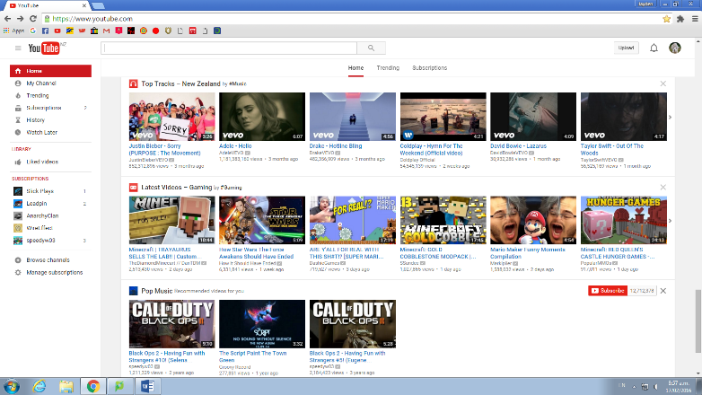 1: YouTube

<https://www.youtube.com/>

This site is YouTube. YouTube is a site where you can upload videos or watch other people’s videos they have uploaded. There are millions of videos on YouTube with a massive genre of videos from gaming videos to tutorial videos. You can also subscribe to other people’s channels so you can see their latest videos as soon as they have been uploaded.

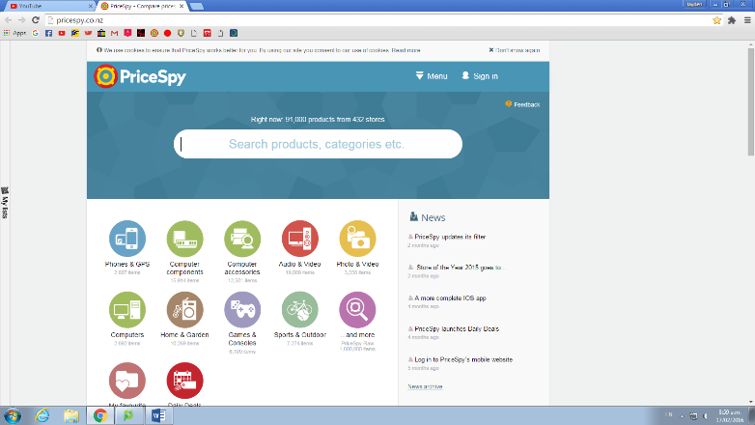2: Price Spy

<http://pricespy.co.nz/>

My second favourite site is Price Spy. Price spy is used to find products you want to buy and the cheapest online shops. I really like this site because it made buying parts to build my computer very simple and a lot more affordable. Also Price Spy has lists that you can create, by creating one of these while you are looking around you can drag and drop items into the list so you get a rough idea of how much the build will cost.

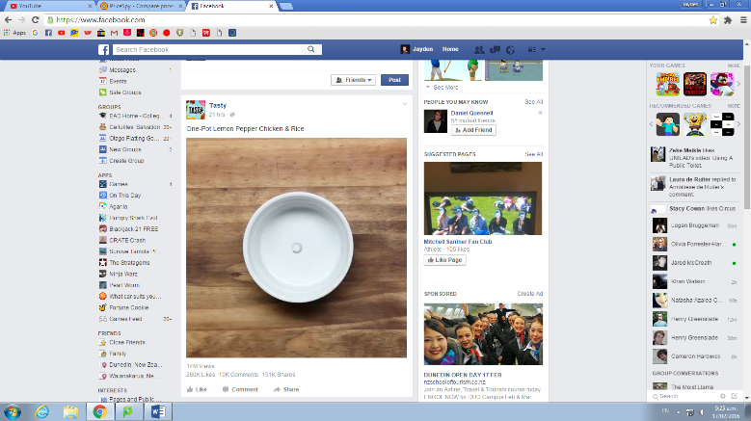 3: Facebook

<https://www.facebook.com/>

Facebook is overall a good site to kill some time on and read about things happening around the world. Another handy thing about Facebook is the Facebook Massager this is an extremely good way to keep in touch with friends and family. Also Facebook is easily accessible on your latest smart phone.

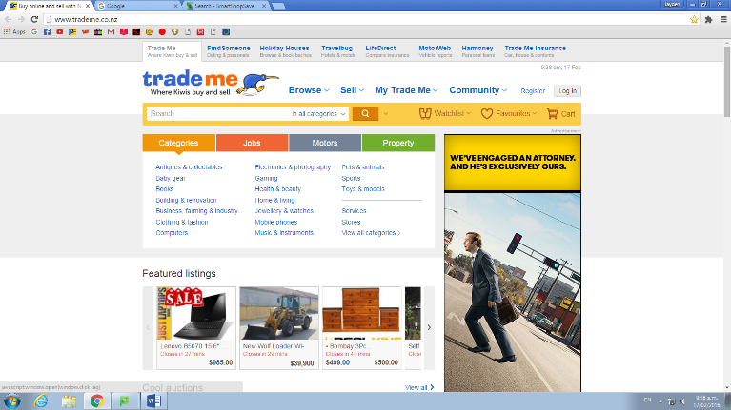4: Trade me

<http://www.trademe.co.nz/>

Trade me is a great site that I have used countless times in my life. If you’re looking to buy something new or used trade me is the place to go to get the best deals. Trade me has hundreds of categories and sub headings that make it even easier to find what you are looking for and filters to search the lowest price to save as much money as possible.